

Super Reflective Pavement Marking Tape

**Product model:** Model PL7000

**Product introduction:** PL7000 super reflective pavement marking tape is pre-made with synthetic rubber with good flexibility and tensile strength; this tape is coated with reflective glass beads with high refractive index. It also uses high performance coating with excellent anti-friction ability. The bottom adopts adhesive with strong adhesion force and weather-resistance to make the tape firmly stuck on the roads. It has better reflective performance than ordinary road signs and is easy for application due to its pre-made nature. It is a kind of new road traffic signs easy for application with long service life.

**Product features:** super reflective and anti-skid performance at night; good flexibility; strong weather resistance; easy application and removing; good self-cleaning performance.

**Application scope:** traffic marking lines for road of various levels; words, arrows and graphics, etc.; warning in dangerous areas; reflective signs for road tunnel, dock, airport, toll station and parting lot, etc.

**Performance and indexes:**

|  |  |  |  |  |
| --- | --- | --- | --- | --- |
| Nature | Typical value | | Unit | Test method |
| PL 7001 | PL 7002 |
| Color | White | Yellow | --- | --- |
| Thickness | 1.9 | 1.9 | mm | GB/T 7125 |
| Retroreflectivity | 500 | 300 | mcd/m2 /lux | GB/T24717 |
| Water resistance | Pass | Pass | --- | GB/T24717 |
| Alkali resistance | Pass | Pass | --- | GB/T24717 |
| Anti-friction | 30 | 30 | mg | GB/T24717 |
| Adhesion | 20 | 20 | N/25mm | GB/T24717 |
| Skid resistance | 45 | 45 | BPN | GB/T24717 |

**Regular specification:** standard length: 33m, 50m

Standard width: 10cm, 15cm, 20cm, 40cm, 45cm; or according to customer’s requiremAvailable color: white, yellow

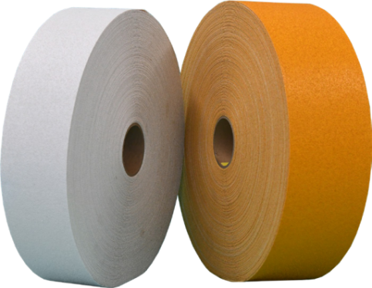

**Application methods:** inlay and overlay; coated with P120 contact primer. 1kg contact primer for 3-5m² road tape application on new roads; actual amount depends on the road situation. Refer to the application instructions.

**Shelf life:** 24 months at normal temperature

**Note:** The listed values are typical only and not intended to serve as product specifications.