

Reflective Pavement Marking Tape of Engineering Level

**Product model:** Model PL5000

**Product introduction:** PL5000 reflective pavement marking tape of engineering level is pre-made with synthetic rubber with good flexibility and tensile strength. This tape is coated with reflective glass-beads that have good reflection at night. With high performance coatings on the tape, it has a strong anti-friction ability. The bottom is coated with a strong and weather resistant adhesive which makes the tape firmly stuck on the roads. It has better reflective performance than ordinary road signs and is easy for application due to its pre-made nature. It is a kind of new road traffic signs easy for installation with long service life.

**Product features:** good reflection; good flexibility; strong weather resistance; easy application and can be pre-made into various marking lines, arrows, words, patterns, colorful signs and stereoscopic signs, etc.

**Application scope:** traffic marking lines for ordinary roads; words, arrows and graphics, etc.; warning in dangerous areas; reflective markings for t dock, airport, toll station and parting lot, etc.

**Performance and indexes:**

|  |  |  |  |  |
| --- | --- | --- | --- | --- |
| Nature | Typical value | | Unit | Test method |
| PL 5001 | PL 5002 |
| Color | White | Yellow | --- | --- |
| Thickness | 1.4 | 1.4 | mm | GB/T 7125 |
| Retroreflectivity | 250 | 175 | mcd/m2 /lux | GB/T24717 |
| Water resistance | Pass | Pass | --- | GB/T24717 |
| Alkali resistance | Pass | Pass | --- | GB/T24717 |
| Anti-friction | 30 | 30 | mg | GB/T24717 |
| Adhesion | 16 | 16 | N/25mm | GB/T24717 |
| Skid resistance | 45 | 45 | BPN | GB/T24717 |

**Regular specification:** standard length: 33m, 50m

Standard width: 10cm, 15cm, 20cm, 40cm, 45cm; or according to customer’s requirements

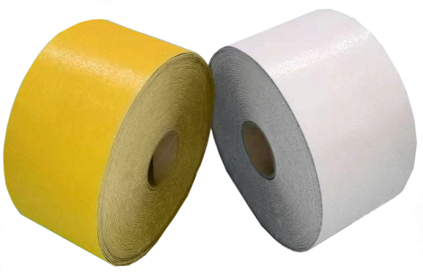Available color: white, yellow, red, blue, black, green

**Application methods:** inlay and overlay; coated with P120 contact primer. 1kg contact primer for 3-5m² road tape application on new roads; actual amount depends on the road situation. Refer to the application instructions.

**Shelf life:** 24 months at normal temperature

**Note:** The listed values are typical only and not intended to serve as product specifications.