Anti-skid Tape --- Universal Anti-skid Product
Product model: Model PL1000

Product introduction: PL1000 anti-skid tape --- universal anti-skid product is made by elastic polymer and anti-skid particles with pressure sensitive adhesive pre-coated. It adopts high performance coating to bond the anti-friction material on the high strength and weather resistant thin membrane. It is a kind of durable universal anti-skid product. The tape has pressure sensitiveness and strong adhesion, which is capable of quick adhesion and well applied on the surface of all kinds of materials.

Product features: good anti-skid and anti-friction performance; strong weather resistance; easy application.

Application scope: applicable for ladders at all sites and ground anti-skid applications in other special areas, such as playground, recreation places, ramp and cross walk, bank of swimming pool, supermarket, working site, pedal, ship deck, unloading dock, factory, dangerous ground, lawn equipment, truck, trailer and industrial device, health/ exercising equipment, golf cart, lifting device of goods van/bus, bleacher, sailing boat and yacht and food processing equipment, etc.

Performance and indexes:
Nature | Typical value | Unit | Test method
 | PL 1000
Color | Black | --- | ---
Thickness | 0.8 | mm | GB/T 7125
Viscosity | 16 | N/25mm | GB/T24717

Regular specification: standard length: 10m
Standard width: 2.5cm, 5.0cm; or according to customer’s requirements
With liner

Application methods:
1. The surface must be clean and dry; apply P120 contact primer if necessary;
2. Cut the tape as required and tear off the anti-sticking backing paper;
3. Apply on the surface in a smooth manner; ensure well conformable to the pavement. The tape has best stickiness at 23℃.
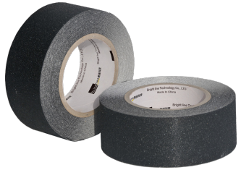
4. Roll over or strike by roller or rubber hammer to ensure firm bonding on the pavement.

Shelf life: 24 months at normal temperature

Note: The listed values are typical only and not intended to serve as product specifications.

