Customized reflective pavement marking tape
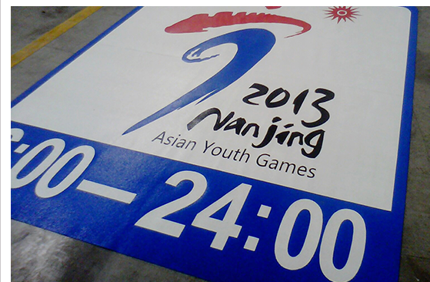
Except the ordinary road traffic signs (words, arrows, graphics), you may also choose reflective tape of relevant levels based on your requirements. We provide customized reflective pavement marking tapes based on graphics provided by our customer. The co
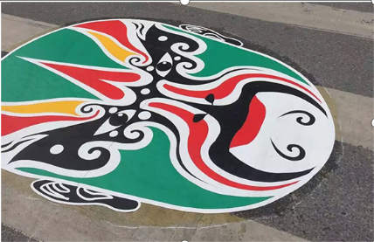
Product features：Use reflective marking tapes of various levels as base materials, which perfectly gains the reflection and weather resistance features, etc. of the base materials; beautiful with better cultrual implication on marking tapes; quick application and easy removing
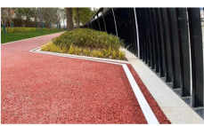
Application scope：Except the ordinary road traffic signs (words, arrows, graphics), you may also choose reflective tape of relevant levels based on your requirements. We provide customized reflective pavement marking tapes based on graphics provided by our customer. The content may include but not limited to all kinds of landscapes, culture show, company logo and enterprise slogan, etc.
Technical parameter：Refer to the technical indexes of base membrane of relevant level
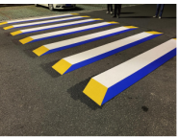
Regular specification：Consult us and customize based on your requirements
Color: various colors
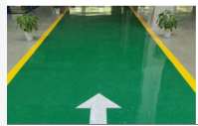
Application methods：Inlay and overlay; coated with P120 contact primer. 1kg contact primer for 3-5m² reflective road tape application on new roads; actual amount depends on the road situation. Refer to the application instructions.
Shelf life：24 months at normal temperature.

